

Requirement & Design Specification
Global Access Management System (GAMS)
Version: 1.0

– Hanoi, August 2022 –

Record of Changes
Version | Date | A*  M, D | In charge | Change Description
V1.0 | 2026-05-28 | A | Lê Văn Hậu | Initial RDS document
V1.1 | 2026-05-28 | M | Lê Văn Hậu | Added all sections and use cases
*A - Added M - Modified D - Deleted

Contents
Record of Changes 2
I. Overview 4
1. User Requirements 4
1.1 Actors 4
1.2 Use Cases 4
2. Overall Functionalities 5
2.1 Screens Flow 5
2.2 Screen Descriptions 5
2.3 Screen Authorization 5
2.4 Non-UI Functions 6
3. System High Level Design 6
3.1 Database Design 6
3.2 Code Packages 7
II. Requirement Specifications 8
1. Authentication & Authorization Feature 8
1.1 UC-1_User Registration 8
2. Common Functions 11
2.1 UC-2_Login System 11
3. Patron Feature 12
3.1 UC-4_ Search and Filter Vehicles 12
3.2 UC-6_Register for Payroll Deduction 13
III. Design Specifications 14
1. <<Feature Name>> 14
1.1 <<SubFeature Name>> 14
1.2 System Access 15
IV. Appendix 19
1. Assumptions & Dependencies 19
2. Limitations & Exclusions 19
3. Business Rules 19
4. .. 19

I. Overview

1. User Requirements

1.1 Actors
[An actor is a person (or sometimes another software system or a hardware device) that interacts with the system to perform a use case. Following are some questions you might ask to help user representatives identify actors
- Who (or what) is notified when something occurs within the system?
- Who (or what) provides information or services to the system?
- Who (or what) helps the system respond to and complete a task?
This part gives the description of system actors, you can follow the table form as below]
# | Actor | Description
1 | Customer | End User who wants to browse, filter, rent vehicles, make payments, and chat with owners.
2 | Vehicle Owner | End User who owns vehicles, creates listings, manages bookings, and tracks earnings.
3 | Administrator | System User responsible for platform management, user moderation, and listing approvals.
4 | System | System Actor executing automated processes, notifications, and balance calculations.
5 | Payment Gateway (VNPay) | External System processing payment transactions securely.

1.2 Use Cases
[A use case (UC) describes a sequence of interactions between a system and an external actor that results in the actor being able to achieve some outcome of value. The names of use cases are always written in the form of a verb followed by an object. Select strong, descriptive names to make it evident from the name that the use case will deliver something valuable for some user]

a. Diagram(s)
[Provide the UC diagram(s) to show the actor-UCs and UC-UC relationships like the sample below. You can have multiple UC diagrams for the system]
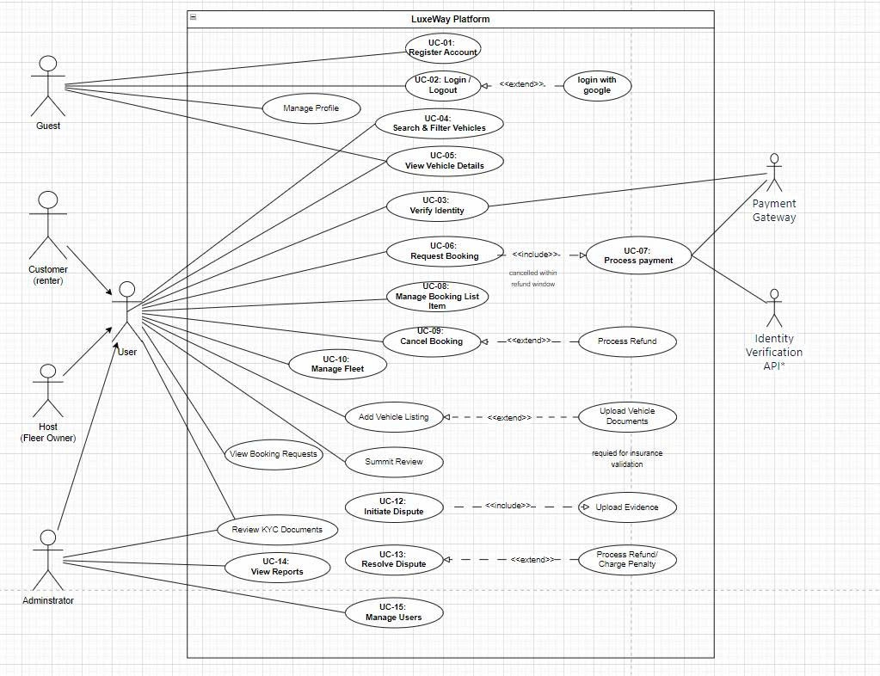

b. Descriptions
This part describes the use cases, you can follow the table form as below]
ID | Feature | Use Case | Use Case Description
UC-1 | Auth & Auth | User Registration | Allows Customers and Owners to register an account.
UC-2 | Auth & Auth | User Login | Authenticates users (Customer, Owner, Admin) into the system.
UC-3 | Common | Search and Filter Vehicles | Allows customers to look up vehicles based on various criteria.
UC-4 | Common | Create Booking | Enables customers to book an available vehicle for specific dates.
UC-5 | Common | Make Payment | Connects with VNPay gateway to process booking payments.
UC-6 | Customer | View Booking History | Displays a historical list of all bookings made by the customer.
UC-7 | Customer | Leave Review and Rating | Allows evaluation of vehicles after booking completion.
UC-8 | Customer | Chat with Vehicle Owner | Real-time messaging channel between customers and owners.
UC-9 | Owner | List Vehicle | Allows owners to submit new vehicles for admin approval.
UC-10 | Owner | Manage Vehicle Listings | Updates or modifies existing listed vehicles.
UC-11 | Owner | View Earnings | Tracks revenue streams and historical transaction data for owners.
UC-12 | Admin | Manage Users | Activates, suspends, or deletes system accounts.
UC-13 | Admin | Approve Vehicle Listings | Audits pending vehicle submissions before publishing.
UC-14 | Admin | View Analytics Dashboard | Provides a graphical overview of system data and financials.

2. Overall Functionalities

2.1 Screens Flow
[This part shows the system screens and the relationship among screens. You can draw the Screens Flow for the system in the form of diagram as below. Please note that beside the normal flat screen, we might have the oval notation for pop-up screen (Import Order) or a screen with multiple information tab (Order Details), etc. You may also use text or background format for different visuality purpose]
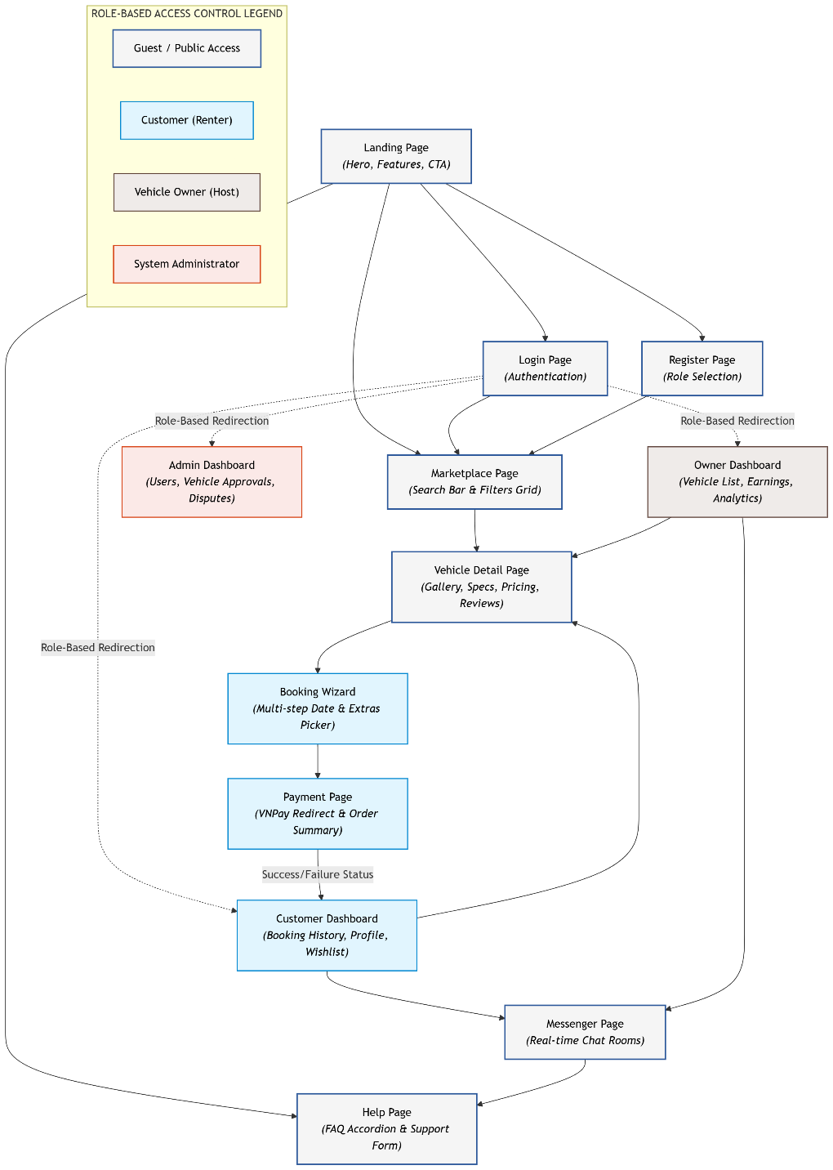

2.2 Screen Descriptions
[Provide the descriptions for the screens in the Screens Flow above]
# | Feature | Screen | Description
1 | Auth & Auth | Landing Page | Introduce platform, key features, and dynamic call-to-actions.
2 | Auth & Auth | Login Page | Handles credentials input for user authentication.
3 | Auth & Auth | Register Page | Dynamic form collecting role and contact details for registration.
4 | Common | Marketplace Page | Core search console displaying interactive vehicle lists.
5 | Common | Vehicle Detail Page | Complete information hub for a single vehicle listing.
6 | Common | Booking Wizard | Multi-step process to reserve dates, extras, and review costs.
7 | Common | Payment Page | Order summary details with gateway integration trigger.
8 | Customer | Customer Dashboard | Private workspace for customers to look up orders and history.
9 | Owner | Owner Dashboard | Work center containing listings, rental orders, and revenue.
10 | Admin | Admin Dashboard | Complete platform console for data oversight and compliance.
11 | Common | Messenger Page | Standard chat splitview containing contact logs and status triggers.

2.3 Screen Authorization
[Provide the system roles authorization to the system features (down to screens, and event to the screen activities if applicable) in the table form as below – replace Role1, Role2,… with your specific system user role names]
Screen | Customer | Owner | Admin | Anonymous
Landing Page | ✅ | ✅ | ✅ | ✅
Login Page | ✅ | ✅ | ✅ | ✅
Register Page | ✅ | ✅ | ✅ | ✅
Marketplace Page | ✅ | ✅ | ✅ | ❌
Vehicle Detail Page | ✅ | ✅ | ✅ | ❌
Booking Wizard | ✅ | ❌ | ❌ | ❌
Payment Page | ✅ | ❌ | ❌ | ❌
Customer Dashboard | ✅ | ❌ | ❌ | ❌
Owner Dashboard | ❌ | ✅ | ❌ | ❌
Admin Dashboard | ❌ | ❌ | ✅ | ❌
Messenger Page | ✅ | ✅ | ❌ | ❌

2.4 Non-UI Functions
[Provide the descriptions for the functions which have no UI (or not screens), i.e batch/cron job, service, API, etc.]
# | Feature | System Function | Description
1 | System Automation | Auto Notification | Triggers in-app alerts on core object adjustments.
2 | System Automation | Email Sending | Fires receipt, contract, and token messages via SMTP.
3 | Payments | Payment Verification | Parses cryptographical callback hashes from VNPay transactions.
4 | Booking Engine | Availability Check | Evaluates datetime conflict parameters within reservation databases.
5 | Evaluation Engine | Rating Calculation | Recomputes moving mathematical averages upon review ingestion.

3. System High Level Design

3.1 Database Design
[Provide the tables relationship like example below]

a. Database Schema
Module 1: User & Core Profiles (Người dùng)
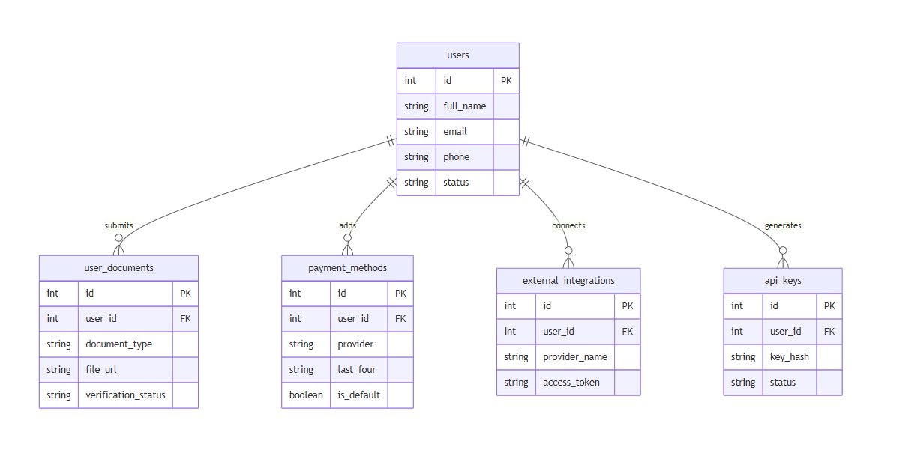
Module 2: Vehicle Management (Quản lý xe)

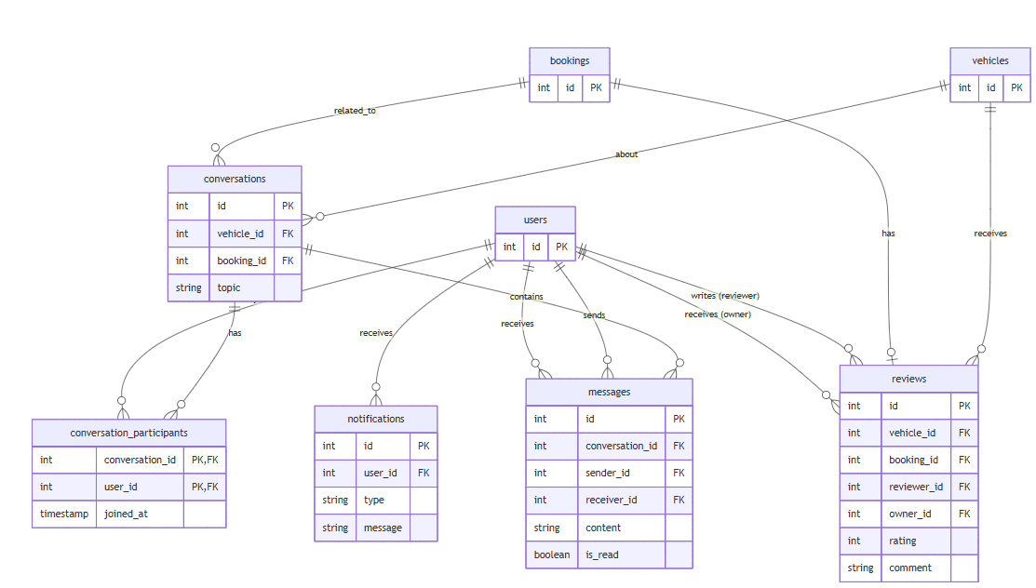
Module 3: Booking & Transactions (Đặt xe & Giao dịch)

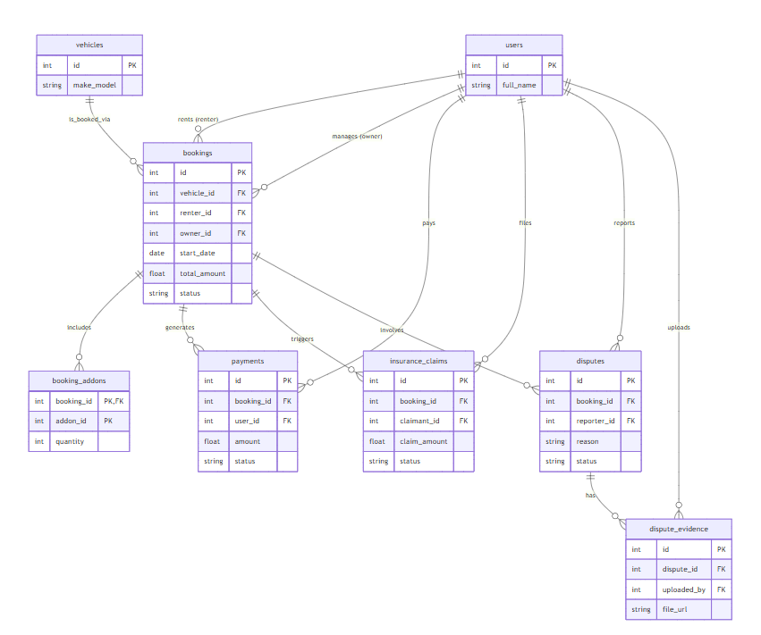

Module 4: Communication & Feedback (Giao tiếp & Đánh giá)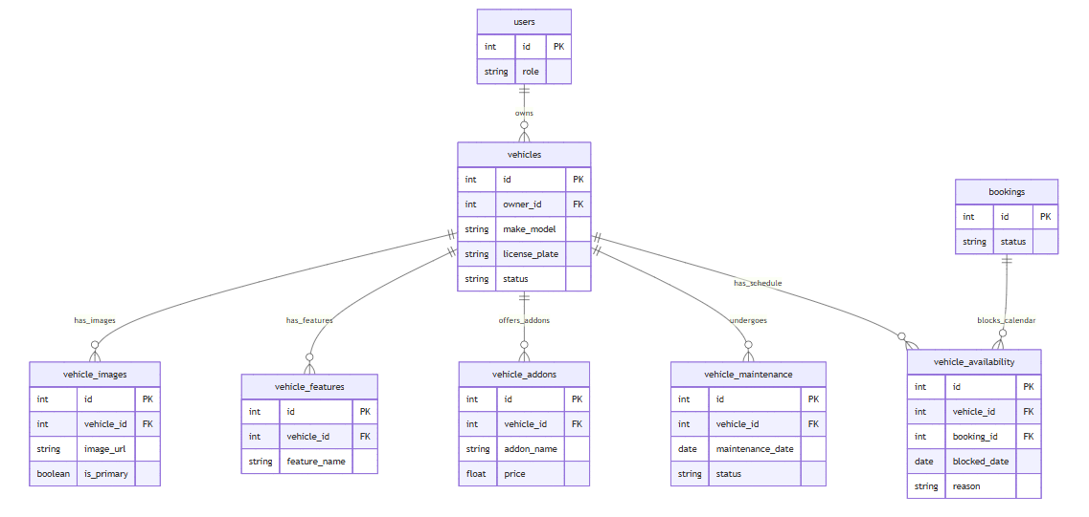

b. Table Descriptions
No | Table | Description
01 | users | Stores account information for all users (renters, owners, admins).  - Primary keys: id  - Foreign keys: None
02 | user_documents | Stores user verification documents such as driver licenses and identity cards.  - Primary keys: id  - Foreign keys: user_id
03 | payment_methods | Stores users' payment methods and default payment preferences.  - Primary keys: id  - Foreign keys: user_id
04 | external_integrations | Stores third-party service integration information for users.  - Primary keys: id  - Foreign keys: user_id
05 | api_keys | Stores API credentials generated by users for external access.  - Primary keys: id  - Foreign keys: user_id
06 | vehicles | Stores vehicles available for rental on the platform.  - Primary keys: id  - Foreign keys: owner_id
07 | vehicle_images | Stores images associated with vehicles.  - Primary keys: id  - Foreign keys: vehicle_id
08 | vehicle_features | Stores features and specifications of vehicles.  - Primary keys: id  - Foreign keys: vehicle_id
09 | vehicle_addons | Stores optional add-on services offered with vehicles.  - Primary keys: id  - Foreign keys: vehicle_id
10 | vehicle_maintenance | Stores maintenance schedules and records for vehicles.  - Primary keys: id  - Foreign keys: vehicle_id
11 | vehicle_availability | Stores blocked dates and availability schedules for vehicles.  - Primary keys: id  - Foreign keys: vehicle_id, booking_id
12 | bookings | Stores rental booking transactions between renters and vehicle owners.  - Primary keys: id  - Foreign keys: vehicle_id, renter_id, owner_id
13 | booking_addons | Stores selected add-ons associated with bookings.  - Primary keys: booking_id, addon_id  - Foreign keys: booking_id, addon_id
14 | payments | Stores payment transactions related to bookings.  - Primary keys: id  - Foreign keys: booking_id, user_id
15 | insurance_claims | Stores insurance claim requests submitted for bookings.  - Primary keys: id  - Foreign keys: booking_id, claimant_id
16 | disputes | Stores disputes raised by users regarding bookings.  - Primary keys: id  - Foreign keys: booking_id, reporter_id
17 | dispute_evidence | Stores evidence files uploaded to support dispute cases.  - Primary keys: id  - Foreign keys: dispute_id, uploaded_by
18 | conversations | Stores discussion threads related to vehicles or bookings.  - Primary keys: id  - Foreign keys: vehicle_id, booking_id
19 | conversation_participants | Stores participants involved in conversations.  - Primary keys: conversation_id, user_id  - Foreign keys: conversation_id, user_id
20 | messages | Stores messages exchanged between users within conversations.  - Primary keys: id  - Foreign keys: conversation_id, sender_id, receiver_id
21 | notifications | Stores system notifications sent to users.  - Primary keys: id  - Foreign keys: user_id
22 | reviews | Stores ratings and reviews submitted after completed bookings.  - Primary keys: id  - Foreign keys: vehicle_id, booking_id, reviewer_id, owner_id

3.2 Code Packages
[Provide the package diagram for each sub-system. The content of this section including the overall package diagram, the explanation, package and class naming conventions in each package. Please see the sample & description table format below]
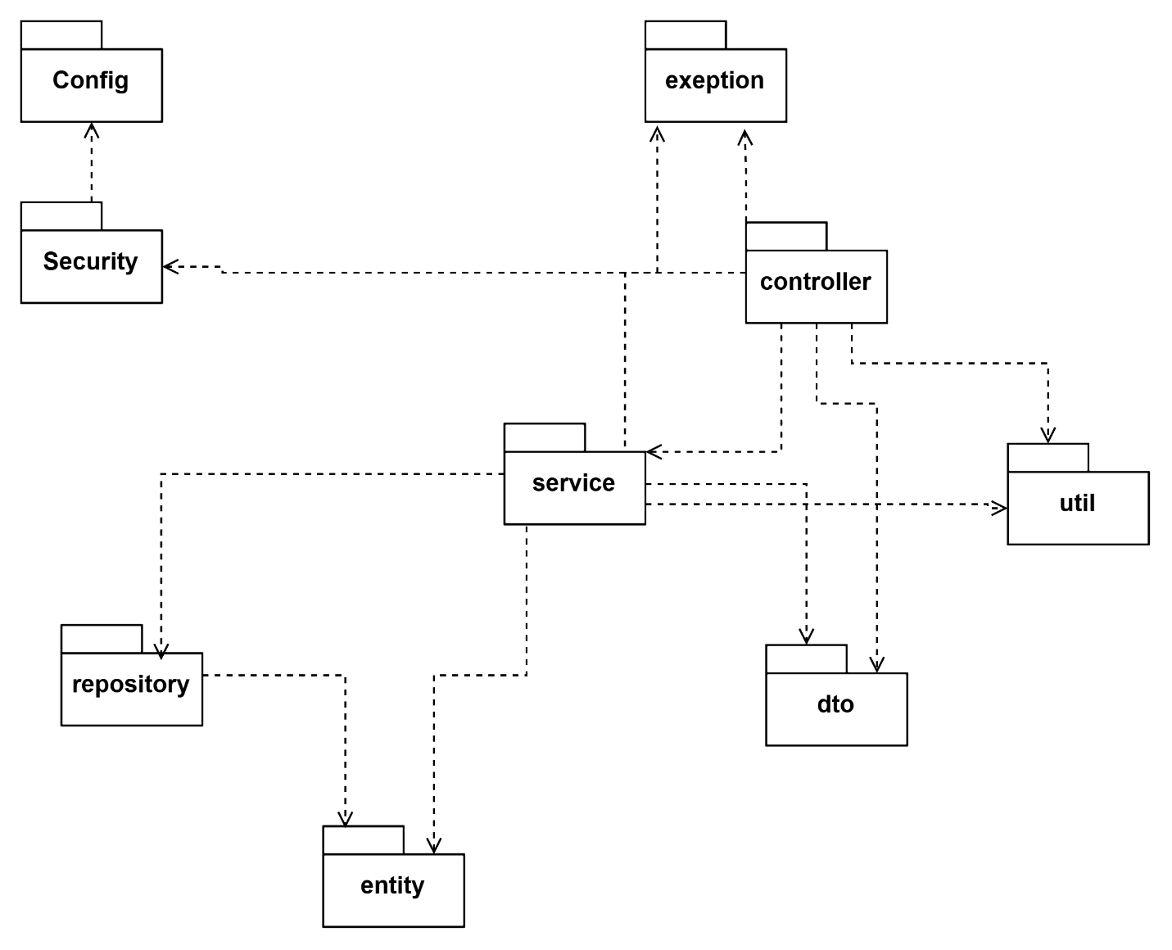
Package descriptions
No | Package | Description
01 | config | Contains configuration classes for system-wide settings (e.g., Database, CORS, Swagger, WebSocket, Redis Cache).
02 | security | Handles security logic and authorization, configures authentication filters (JWT Filter), password encoding, and platform access mechanisms.
03 | controller | Presentation Layer (API Layer); defines HTTP Endpoints (GET, POST, PUT, DELETE), receives requests from the Client, and routes them to the Service.
04 | service | Business Logic Layer; contains core business rules, executes data processing, and manages Transactions before interacting with the database.
05 | repository | Data Access Layer (DAO); provides interfaces (often extending JpaRepository) to execute SQL/ORM queries directly against the database.
06 | entity | Data Model Layer; defines objects (Classes) that map 1-1 with tables in the relational database (containing column structures, primary keys, and foreign keys).
07 | dto | Data Transfer Object package; defines object structures used solely for encapsulating and transferring data between the Client and Server (hiding the actual Entity structure).
08 | exception | Centralized error management; defines Custom Exception classes and a GlobalExceptionHandler to catch system-wide errors and return a standardized response format.
09 | util | Contains shared utility functions/classes used throughout the project (Cross-cutting concerns), e.g., date formatting, string manipulation, encryption/decryption, file uploading.

II. Requirement Specifications

1. 1. Authentication & Authorization Feature

1.1 UC-1_User Registration

a. Functionalities
Provide the functional description for the use cases using the template/guides below
Functional Description Template
UC ID and Name: | UC-1_User Registration
Created By: | Lê Văn Hậu | Date Created: | 28/5/2026
Primary Actor: | Customer, Vehicle Owne | Secondary Actors:
Trigger: | The visitor clicks the account registration link on the Header screen or homepage.
Description: | Allows users to initialize a new account on the system with their desired role
Preconditions: | The user is not logged into any account on the current browser
Postconditions: | A User record is created in a pending activation state; an email containing a verification link is sent.
Normal Flow: | 1.0 User Registration  - The user navigates to the Registration interface.  - The user enters all required information: Email, Password, Confirm Password, First and Last Name.  - The user selects the desired Role (Customer or Vehicle Owner).  - The user clicks the "Register" button.  - The system validates the input data format.  - The system executes a query to check for the existence of the Email in the DB.  - The system encrypts the password and inserts a new User record.  - The system sends an email containing the account verification string via the SMTP protocol.  - The system responds with a successful registration message on the UI screen.
Alternative Flows: | None
Exceptions: | 1.0.E1 Duplicate Email  - The system detects that the registered Email already exists in the DB.  - The data insertion process is canceled; the system throws a warning error prompting the user to use a different email.
Priority: | Must Have
Frequency of Use:
Business Rules: | BR-10 Soft Delete Audit Rule
Other Information:
Assumptions:

Functional Description Contents
Use Case ID and Name
Give each use case a unique integer sequence number identifier. State a concise name for the use case that indicates the value the use case would provide to some user. Begin with an action verb, followed by an object.
Author and Date Created
Enter the name of the person who initially wrote this use case and the date it was written.
Primary and Secondary Actors
An actor is a person or other entity external to the software system being specified who interacts with the system and performs use cases to accomplish tasks. Different actors often correspond to different user classes, or roles, identified from the customer community that will use the product. Name the primary actor that will be initiating this use case and any other secondary actors who will participate in completing execution of the use case.
Trigger
Identify the business event, system event, or user action that initiates the use case. This trigger alerts the system that it should begin testing the preconditions for the use case so it can judge whether to proceed with execution.
Description
Provide a brief description of the reason for and outcome of this use case, or a high-level description of the sequence of actions and the outcome of executing the use case.
Preconditions
List any activities that must take place, or any conditions that must be true, before the use case can be started. The system must be able to test each precondition. Number each precondition. Example: PRE-1: User’s identity has been authenticated.
Postconditions
Describe the state of the system at the successful conclusion of the use case execution. Label each postcondition in the form POST-X, where X is a sequence number. Example: POST-1: Price of item in the database has been updated with the new value.
Normal Flow
Provide a description of the user actions and corresponding system responses that will take place during execution of the use case under normal, expected conditions. This dialog sequence will ultimately lead to accomplishing the goal stated in the use case name and description. Show a numbered list of actions performed by the actor, alternating with responses provided by the system. The normal flow is numbered “X.0”, where “X” is the Use Case ID.
Alternative Flows
Document other successful usage scenarios that can take place within this use case. State the alternative flow, and describe any differences in the sequence of steps that take place. Number each alternative flow in the form “X.Y”, where “X” is the Use Case ID and Y is a sequence number for the alternative flow. For example, “5.3” would indicate the third alternative flow for use case number 5. Indicate where each alternative flow would branch off from the normal flow, and if pertinent, where it would rejoin the normal flow.
Exceptions
Describe any anticipated error conditions that could occur during execution of the use case and how the system is to respond to those conditions. Number each alternative flow in the form “X.Y.EZ”, where “X” is the Use Case ID, Y indicates the normal (0) or alternative (>0) flow during which this exception could take place, “E” indicates an exception, and “Z” is a sequence number for the exceptions. For example “5.0.E2” would indicate the second exception for the normal flow for use case number 5. Indicate where in the normal (or an alternative) flow each exception could occur.
Priority
Indicate the relative priority of implementing the functionality required to allow this use case to be executed. Use the same priority scheme as that used for the functional requirements.
Frequency of Use
Estimate the number of times this use case will be performed per some appropriate unit of time. This gives an early indicator of throughput, concurrent usage loads, and transaction capacity.
Business Rules
List any business rules that influence this use case. Don’t include the business rule text here, just its identifier so the reader can find it in another repository when needed.
Other Information
Identify any additional requirements, such as quality attributes, for the use case that may need to be addressed during design or implementation. Also list any associated functional requirements that aren’t a direct part of the use case flows but which a developer needs to know about. Describe what should happen if the use case execution fails for some unanticipated or systemic reason (e.g., loss of network connectivity, timeout). If the use case results in a durable state change in a database or the outside world, state whether the change is rolled back, completed correctly, partially completed with a known state, or left in an undetermined state as a result of the exception.
Assumptions
List any assumptions that were made regarding this use case or how it might execute.

b. Business Rules
Provide the business rules those are applied only to the use case
ID | Business Rule | Business Rule Description
BR-10 | Soft Delete Preservation | Data state shifts to flagged attributes during deletions; real records remain for tracking.

2. Common Functions

2.1 UC-2_Login System

a. Functional Description
UC ID and Name: | UC-2_Login System
Created By: | Lê Văn Hậu | Date Created: | 28/5/2026
Primary Actor: | Customer, Vehicle Owner, Administrator | Secondary Actors: | None
Trigger: | The user clicks the Login button or attempts unauthorized access to a secured Endpoint.
Description: | Verifies account identity information to grant login permission and distribute a security Token
Preconditions: | The user has a valid account stored in the storage system.
Postconditions: | The user logs in successfully; the system initializes an encrypted JWT string and stores it in the Client-side memory.
Normal Flow | 2.0 Login System  - The user accesses the Login page.  - The user provides their Email and Password.  - The user clicks the "Login" button.  - The system cross-checks the information through the Repository layer.  - The system generates an Access Token string based on the standard JWT format.  - The system pushes the Token data to be stored on the browser side.  - The system redirects the user to the dashboard corresponding to their Role.
Alternative Flows: | 2.1 Google Login  1. User chooses to login system using Google account  2. System redirects the user to the Google’s Login screen  3. User types in the Google account details and chooses to login  4. Google validates user’s login information successfully and redirect him/her back to the system  5. Return to step 5 of normal flow.
Exceptions: | 2.0.E1 Incorrect Login Credentials  - The authentication information does not match the database.  - The system displays a detailed error message on the screen for the user to re-enter their credentials.
Priority: | Must Have
Frequency of Use:
Business Rules: | FR1, FR2, FR3
Other Information:
Assumptions:

b. Business Rules
ID | Business Rule | Business Rule Description
FR1 | Password Encoding | User’s password must be encoded with MD5 hashing
FR2 | Invalid Logging In | User can’t be authenticated to login the system if below cases  - His/her logging-in details are incorrect  - His/her account has not been verified  - His/her account has been locked or blocked
FR3 | Account Locking | If user inputs wrong logging-in details 6 times continuously, his/her account would be locked in 30 minutes

3. Customer Feature

3.1 UC-4_Search and Filter Vehicles

a. Functional Description
ID and Name: | UC-4_Search and Filter Vehicles
Created By: | Le Van Hau | Date Created: | 28/5/2026
Primary Actor: | Customer | Secondary Actors:
Description: | Executes text string searches and filters vehicle information in real-time
Trigger: | The customer accesses the search module of the e-commerce marketplace.
Preconditions: | The user account is in an activated state and logged into the system
Postconditions: | The list of vehicles meeting the search criteria is sorted and visually rendered.
Normal Flow: | 4.0 Search and Filter Vehicles  - The user accesses the Marketplace page.  - The user enters search keywords or selects filter parameters (brand, price range, location).  - The system captures the data change event and converts it into SQL Query parameters.  - The system paginates the result data and returns an array of vehicle data.  - The user interface renders the data into a grid list of vehicle cards.
Alternative Flows: | 4.1 Clear Filters:  - The user clicks the "Clear Filters" button on the UI.  - The system resets all filter configurations to their default empty states.  - The system executes a new query without conditions and returns the default list of available vehicles.
Exceptions: | • 3.0.E1 No Vehicles Found:  - The system executes the query but detects no records matching the specified criteria.  - The UI displays an empty state illustration with the message "No vehicles found" and suggests the user adjust or broaden their filters.  • 3.0.E2 Search Timeout:  - The search query exceeds the system's maximum allowed execution time due to heavy load.  - The system aborts the request and displays a "Connection timeout, please try again later" error message.
Priority: | High
Frequency of Use: | High (Continuously accessed by customers multiple times during a typical browsing session).
Business Rules: | BR-4, BR-5
Other Information: | For optimal query performance and fuzzy text matching, the search module may require integration with a full-text search engine or an in-memory datastore (e.g., Elasticsearch, Redis).
Assumptions: | • All active vehicles in the database have properly structured and fully indexed metadata (price, geolocation, brand, status).  • The data between the primary transactional database and the search index is synchronized in near real-time.

b. Business Rules
ID | Business Rule | Business Rule Description
BR-4 | Search Pagination Limit: | The system must restrict the maximum number of vehicle records returned per single API request/page to a predefined limit (e.g., 20 or 50 items) to ensure optimal rendering performance.
BR-5 | Default Sorting Logic | If the user does not specify a distinct sorting rule, the system defaults to sorting search results by "Highest Relevance" or "Newly Added".

3.2 UC-6_Request Booking

a. Functional Description
ID and Name: | UC-6 Request Booking
Created By: | Le Van Hau | Date Created: | 28/5/2026
Primary Actor: | Patron | Secondary Actors:
Description: | Collects car rental parameters to initialize a booking order in a pending financial processing state.
Trigger: | The customer clicks the "Book Now" button on the vehicle details screen.
Preconditions: | PRE-1. The target vehicle must be in an active state (ACTIVE) and have an open schedule during the requested date range.
Postconditions: | The booking order is successfully created in the DB with the status attribute set to PENDING.
Normal Flow: | Normal Flow: 6.0 Create Booking  - The user selects a car and views the vehicle details.  - The user specifies the pick-up date and time, as well as the return date and time, via the UI calendar component.  - The system checks the logical validity of the time and runs a background process to check for scheduling conflicts.  - The system confirms the vehicle is fully available.  - The user configures specific pick-up and return locations.  - The user opts to add additional services (trip insurance, GPS tracking device...).  - The system automatically calculates the total order value based on the pricing configuration formula.  - The user reviews the booking invoice summary table.  - The user clicks the "Confirm Booking" button.  - The system saves the booking order into the data table along with the initial status tag PENDING.  - The system automatically forwards the Client's processing flow to the Payment page.
Alternative Flows: | 6.1 Modify Booking Parameters:  - At step 8, before confirming, the user decides to change the rental dates or optional services.  - The system dynamically re-validates the schedule and recalculates the total order value.  - The flow resumes from step 8.
Exceptions: | - 6.0.E1 Concurrent Booking Conflict:  - At step 9, when the user clicks "Confirm Booking", the system detects that another user has just successfully booked the exact same vehicle for overlapping dates.  - The system aborts the booking process.  - The UI displays an error message: "This vehicle is no longer available for the selected dates. Please choose another time or a different vehicle."  - 6.0.E2 Invalid Return Location:  - The system detects that the custom return location exceeds the maximum allowed distance from the owner's base location.  - The system prompts the user to select a valid location or accept an extra delivery fee.
Priority: | Must Have
Business Rules: | BR-1 Br-3 Br-2
Other Information: | To prevent booking abandonment from locking up vehicle availability, the system should implement a temporary hold mechanism (e.g., locking the vehicle's calendar for 15 minutes) while the user is redirected to the payment gateway (UC-5). If payment is not completed within this timeframe, the PENDING order is automatically cancelled, and the dates are freed up.

b. Business Rules
ID | Business Rule | Business Rule Description
BR-1 | Date Validation Rule | The return date must strictly follow the pick-up date in a linear chronological sequence.
BR-2 | Minimum Rental Period | The minimum vehicle rental period accepted by the system for processing is 1 day (24 hours).
BR-3 | Booking Self-Exclusion | The system imposes a constraint that blocks Vehicle Owners from booking their own vehicles.

III. Design Specifications
1.1 Authentication Management
a. User Login This screen allows users (Customers, Owners, Admins) to be authenticated into the LuxeWay system functionalities. Related use cases:
UC01 - Login System
UI Design The User Login screen provides a simple form with Email and Password input fields, along with social login options (Google) and links for registration or forgotten passwords.
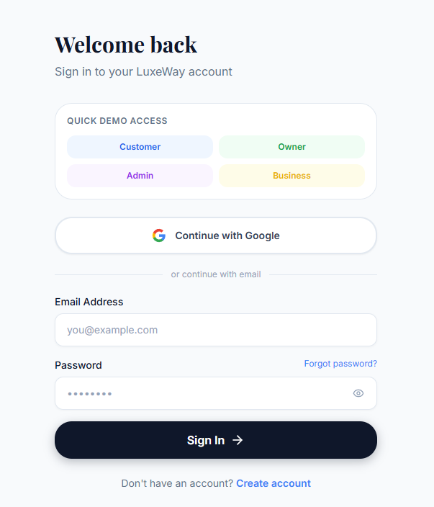
<<Mockup prototype>>
Field Name | Field Type | Description
Field Group Name
Email* | Text Box | This is for user to input valid email address for logging in
Password* | Password Box | This is for user to input password for logging in
Login | Button | User clicks to authenticate him/herself into the system with provided email & password
Register | Button | User clicks to redirect to the User Register page for registering new user account
Forgot Password? | Hyperlink | User clicks to redirect to the Password Reset page
Login with Google | Hyperlink | Allow user to login with his/her Google account

Database Access :This function reads user credentials from the database to verify identity and retrieve user roles/details for the JWT token generation.
Table | CRUD | Description
User | R | Verify Email & Password information and check account status

SQL Commands
[Provide the detailed SQL (select, insert, update...) which are used in implementing the screen/function]

SQL Commands:
1/ Verify UserName & Password information
SELECT id, email, password, first_name, last_name, display_name, role, avatar
FROM users
WHERE email = ? AND deleted_at IS NULL

2. Vehicle Management
2.1 Vehicle Listing
a. Vehicle Details This screen displays the complete, detailed information of a specific vehicle (Car/Motorbike) including specifications, pricing, and owner details. Related use cases:
UC15 - View Vehicle Details
UC18 - Create Vehicle Booking
UI Design The page layout includes a main image gallery of the vehicle, a section for specifications (Seats, Transmission, Fuel Type, etc.), pricing details per day/week, and a "Book Now" CTA (Call to Action) block.
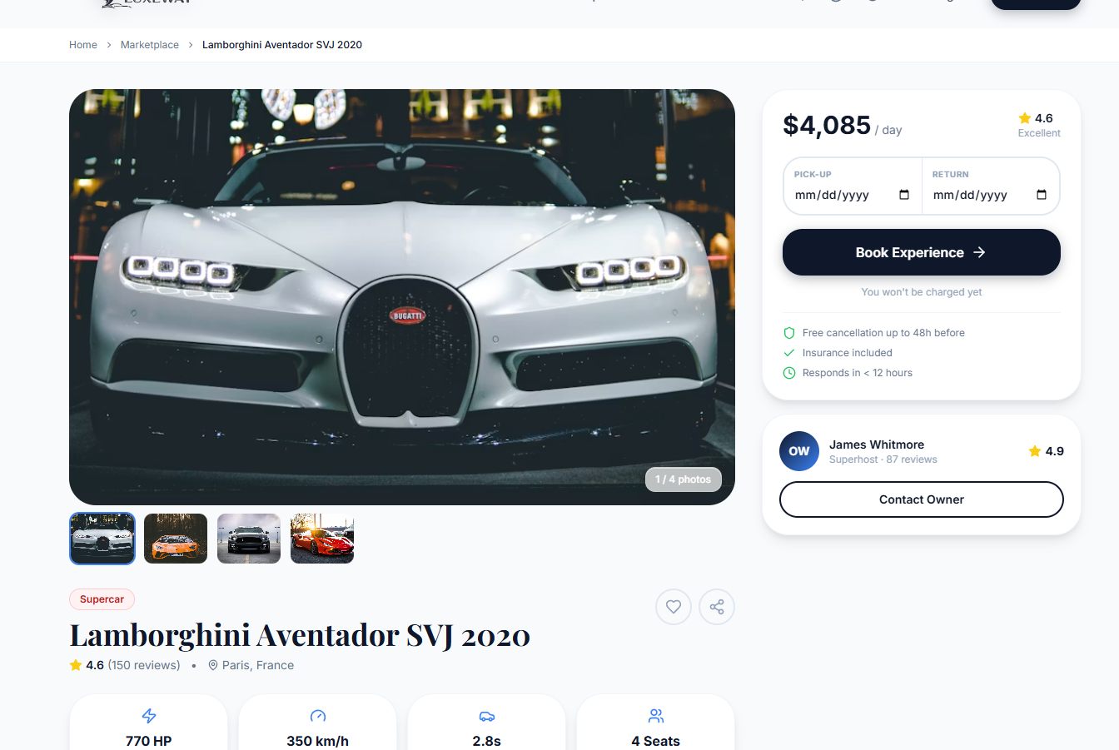
Field Name | Field Type | Description
Field Group Name
Main Image Gallery | Image Carousel | Displays high-quality images of the vehicle
Vehicle Name | Text Label | Displays the Brand, Model, and Year of the vehicle
Price Per Day | Text Label | Displays the rental price per day
Specifications | Data Grid | Displays engine capacity, seats, transmission, fuel type, etc.
Owner Info | Card/Panel | Displays owner's avatar, name, and rating
Description | Text Area | Detailed description provided by the vehicle owner
Book Now | Button | Click to open the Booking checkout process
Database Access: This function reads vehicle data, its owner, and related specifications from the database to present to the user.
Table | CRUD | Description
Vehicle | R | Fetch core vehicle details (name, brand, price, year, etc.)
User (Owner) | R | Fetch the vehicle owner's profile information
SQL Commands:
1/ Fetch vehicle details by ID
SELECT v.id, v.name, v.brand, v.model, v.year, v.category, v.description,
v.price_per_day, v.price_per_week, v.deposit, v.city, v.address,
v.seats, v.transmission, v.fuel_type, v.thumbnail_url
FROM vehicle v
WHERE v.id = ? AND v.deleted_at IS NULL
2/ Fetch owner details
SELECT u.id, u.first_name, u.last_name, u.display_name, u.avatar
FROM users u
WHERE u.id = ?

IV. Appendix

1. Assumptions & Dependencies
[Record any assumptions that were made when conceiving the project and writing this vision and scope document. Note any major dependencies the project must rely upon for success, such as specific technologies, third-party vendors, development partners, or other business relationships.]
Assumptions:
AS-1: Users must have a valid driver's license (or relevant permits) and meet the minimum age requirement to successfully book and operate a vehicle.
AS-2: Vehicle owners are responsible for ensuring their registered vehicles are in good, safe working condition and comply with local traffic regulations.
AS-3: Users have access to smartphones or computers with a stable internet connection to use the LuxeWay application.
Dependencies:
DE-1: The platform relies heavily on third-party payment gateways (e.g., VNPay, Stripe) for processing online transactions securely.
DE-2: The system depends on external mapping and geolocation APIs (e.g., Google Maps API) for displaying vehicle locations and distance calculations.
DE-3: The AI features (e.g., Copilot, AI Predictive Analytics) depend on the continuous availability and performance of third-party AI service providers (e.g., OpenAI, Gemini).
DE-4: Notifications (Email/SMS) are dependent on external communication providers (e.g., SendGrid, Twilio).
>>

2. Limitations & Exclusions
[Identify any product features or characteristics that a stakeholder might anticipate, but which are not planned to be included in the new product]
LE-1 (Physical Delivery): The system does not natively manage or guarantee physical vehicle delivery. The renter must pick up the vehicle at the owner's designated location unless an external agreement is made between the two parties.
LE-2 (Insurance Liability): The platform acts strictly as an intermediary. LuxeWay does not directly provide vehicle insurance or assume liability for accidents/damages. Users are strongly encouraged to have their own coverage or utilize third-party insurance packages offered during the checkout phase.
LE-3 (Geographical Limits): The system's initial launch phase is limited to operations within specific supported regions (e.g., Vietnam) and does not support cross-border vehicle rentals.
LE-4 (Real-time IoT Tracking): While the system manages vehicle locations based on manual inputs or mobile GPS, it does not include built-in IoT hardware integration for real-time live tracking of vehicles unless the owner installs and integrates a separate API.

3. Business Rules
[Provide common business rules that you must follow. The information can be provided in the table format as the sample below]
<<Sample
ID | Category | Rule Definition
BR-01 | Constraints | A vehicle cannot be booked by multiple users for overlapping time periods. The system must block out dates once a booking is confirmed.
BR-02 | Constraints | A booking request must be submitted at least 12 hours prior to the intended pickup time to allow the owner to prepare the vehicle.
BR-03 | Facts | All payments for a booking (including deposits, if applicable) must be successfully verified before the booking status can change to "Confirmed".
BR-04 | Facts | A user (renter) is only allowed to leave a rating and review for a vehicle after their booking status has been marked as "Completed".
BR-05 | Computations | The total booking price is calculated as: (Rental Price per Day * Number of Days) + Platform Fee + Optional Insurance/Add-on Fees.
BR-06 | Computations | If a booking is canceled within 24 hours of the scheduled pickup time, a cancellation penalty is applied (e.g., computed as 50% of the first day's rental price), and the remainder is refunded.
BR-07 | Constraints | Vehicle owners must complete identity verification (KYC/Owner Verification) before their vehicle listings can be publicly visible in the search results.
BR-08 | Facts | Support tickets must be responded to by an admin or support staff within a 24-hour SLA (Service Level Agreement) window.
BR-01 | Constraints | A vehicle cannot be booked by multiple users for overlapping time periods. The system must block out dates once a booking is confirmed.
BR-02 | Constraints | A booking request must be submitted at least 12 hours prior to the intended pickup time to allow the owner to prepare the vehicle.
>>

4. ..

